Write a program for Alpha-Beta Pruning algorithm for gaming using python code

Aim :To implement the Alpha-Beta Pruning Algorithm for game playing in Python.
Procedure:
Define the Alpha-Beta function.
Initialize alpha = -∞ and beta = +∞.
If it is the maximizing player's turn, choose the maximum value and update alpha.
If it is the minimizing player's turn, choose the minimum value and update beta.
Stop exploring a branch when beta ≤ alpha (pruning).
Return the optimal value.

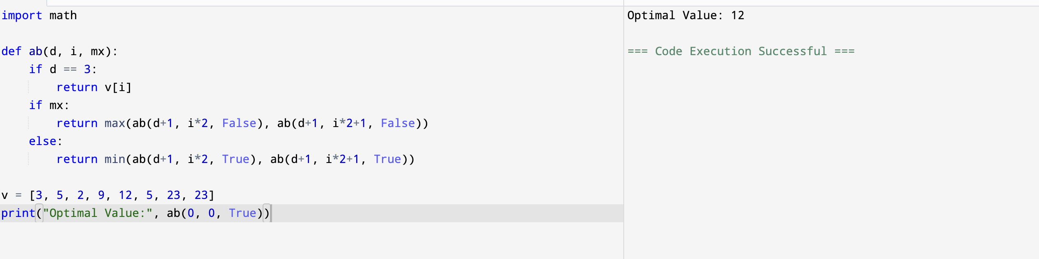
Output:

Result: Hence, Alpha-Beta Pruning Algorithm for gaming has been solved

